**Abstract**

**Automatic Parking System Using Binary Semaphores**

**Sahil Jain1, Vijaya Kumar K2**

**1UG Student, SCOPE, VIT University, India**

**2Associate Professor, SCOPE, VIT University, India**

This paper mainly focuses on the Parking problem which is generally seen in big places like shopping mall, tourist points and market places. People waste a large amount of time to park their vehicles, so we came up with a solution to deal with this problem. We developed an Automatic Parking System which will be deployed in Parking Space Machines. We have used Semaphores and First Come First Serve (FCFS) Synchronization so that we can avoid the deadlock situation and conflict on which vehicle should the machine park first. Our solution is cost efficient and can be used in the real Parking Spaces. We have implemented our system using C language.

**Keywords:** Automatic Parking, Semaphores, FCFS Synchronization, Cost Efficient Parking System.

**1. Introduction**

We have designed our system for two different type of vehicles Two-Wheelers and Four-Wheelers because their size varies and the space they need for parking is also different so to save space we have done this. Many Researchers and Engineers before us provided solution for the Parking System but all those system were costly, here we are using semaphores which will reduce cost.

We have implemented total seven modules in our program which are:

* Arrival Of Vehicles
* Total No. of Vehicles Parked
* Total No. of Two-Wheelers Parked
* Total No. of Four-Wheelers Parked
* Display the Order of Vehicle Parked
* Display the Wait Queue
* Departure of the Vehicle

All of these modules were implemented using C language and Operating Systems Concepts like Semaphores, FCFS Synchronization.

Basically Whenever a vehicles come inside the parking space the owner/driver of the vehicles places it on the automatic parking machines and leaves, Machine then identifies the free slot in the parking space and park the vehicle. Parking of vehicle takes time, here assume it takes 2 min to park a vehicle so in this 2 min no other vehicles can be parked and they have to wait in queue which is maintained by the machine on the basis of FCFS Synchronization. Sometimes two Vehicles at the same time may want to be get parked which will arise the deadlock situation.

So, to avoid deadlock situation we are using binary semaphores which will help us to park one vehicle at a time. What happens is whenever one vehicles get into the parking process it uses P Semaphore function which decrements the counter to zero so until when the counter becomes 1 machine will not process any other vehicles. And when the vehicle is parked the counter is incremented to 1 using V Semaphore, notifying that machine can process other vehicles now.

Code to implement binary semaphores is shown below:

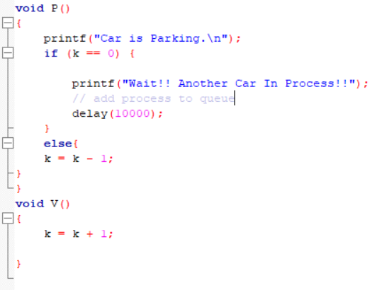

Figure : Code to Implement Binary Semaphores

**2. Literature Review**

Many Researchers and Engineers before us proposed many automatic parking system and there research was very helpful for us to complete our project.

**[P. Kahn et al, 2018]** They proposed a technique for dealing with a parking framework including getting a demand for a parking area from a client from a smartphone , choosing an accessible spot , and managing the client to the accessible spot . The strategy in on epitome additionally contains denoting the parking area . In one encapsulation , the client may likewise be given direction back to the stamped parking area.

**[A. Shahzad et al, 2018]** This investigation is included the few parking focuses efficiently spread over the few areas and traceable over the accessible graphical guide, and the general data is effortlessly open utilizing keen gadgets. For parking data, a shrewd web application which is another critical module of this investigation is outlined, with which the SVPS framework's enlisted clients can get to every one of the administrations accommodated keen vehicle parking looking and reservation in effective and solid ways. A coordinated system approach, RFID (radio recurrence recognizable proof) and remote sensors arrange (WSN), called RF-WSN, is utilized to recover the continuous data from the introduced and designed sensor gadgets in RFID-WSN organize.

**[Y. R. Rao, 2017]** In this investigation he outline a Smart Parking System (SPS) which empowers the client to discover the closest parking region and gives accessibility of parking openings in that separate parking region. Furthermore, it for the most part centre around decreasing the time in finding the parking parcels and furthermore it stays away from the superfluous going through filled parking parts in a parking region. In this manner it lessens the fuel utilization which thusly decreases carbon impressions in a climate.

**[E. I. Vlahogianni et al, 2016]** They presented methodological system for numerous means ahead parking accessibility expectation is displayed. Two distinct sorts of expectations are given: 1. the likelihood a free space to keep being free in resulting time interims, and 2. the fleeting parking inhabitancy forecast in chosen districts of an urban street organize. The accessible information originates from a wide system of on-road parking sensors in the "smart" city of Santander, Spain. The sensor arrange is divided in four unique locales and, at that point, survival and neural system models are created for every area independently.

**[J. Bales et al, 2018]** A parking assist system for a vehicle is given that incorporates a vicinity sensor arranged to detect a separation to a deterrent, a parking controller designed to yield a separation to target flag and a scheduler arranged to process the separation to target flag and yield a separation mistake flag to a control module designed to longitudinally control the vehicle. The scheduler is arranged to process both a static and a dynamic separation to target flag.

**3. Implementation**

Our implementation plan was very simple we first created our Arrival and Departure function and then used a array to Display the order of vehicle parked. Semaphore was used to stop other vehicle for making a entry on the parking machine when other vehicle was still in the process of parking. FCFS synchronization was implemented to store the vehicles in a first come first serve manner and their vehicle number is stored in wait queue to avoid confusion.

Below the code and output of the modules implemented are shown to understand our system better:

**Arrival of Vehicle**

In this module we are going to add vehicle according to their type, we are going to use both the binary semaphores to avoid deadlock and we will add the waiting vehicles in wait queue.

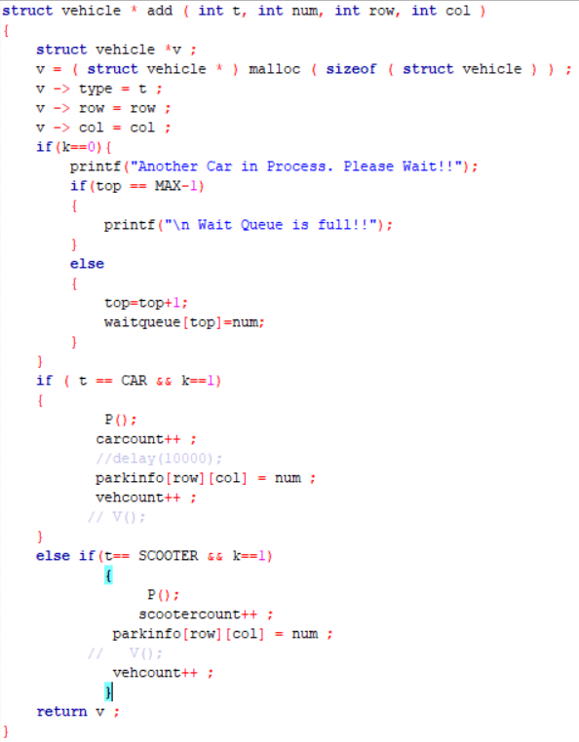

Figure : Code to Implement Arrival Function

**Departure**

This function will remove the vehicle from the array and empty the slot.

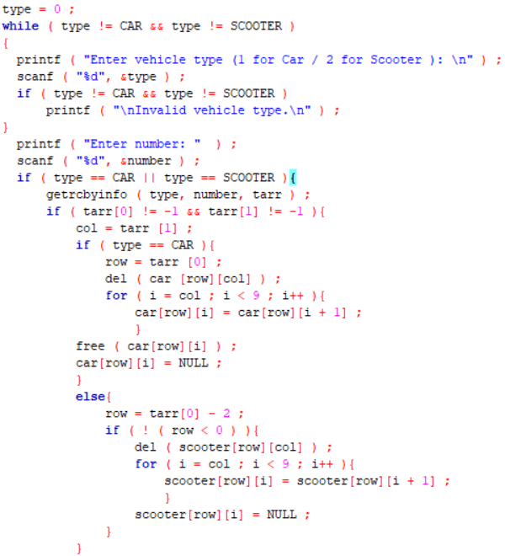

Figure : Code to Implement Departure Function

**Display**

This function displays the order in which vehicles are parked.

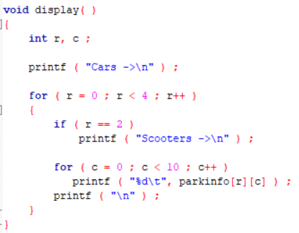

Figure : Code to Implement Display Function

**Display Wait Queue**

This function will display the order of vehicles waiting in the wait queue

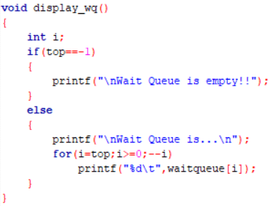

Figure : Code to Display Wait Queue

**Screenshot of OUTPUT**

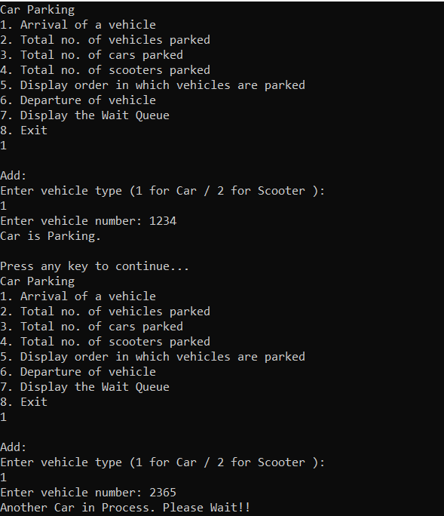

Figure : Screenshot of Output-1

Figure 6 shows the output of adding a vehicle in the system.

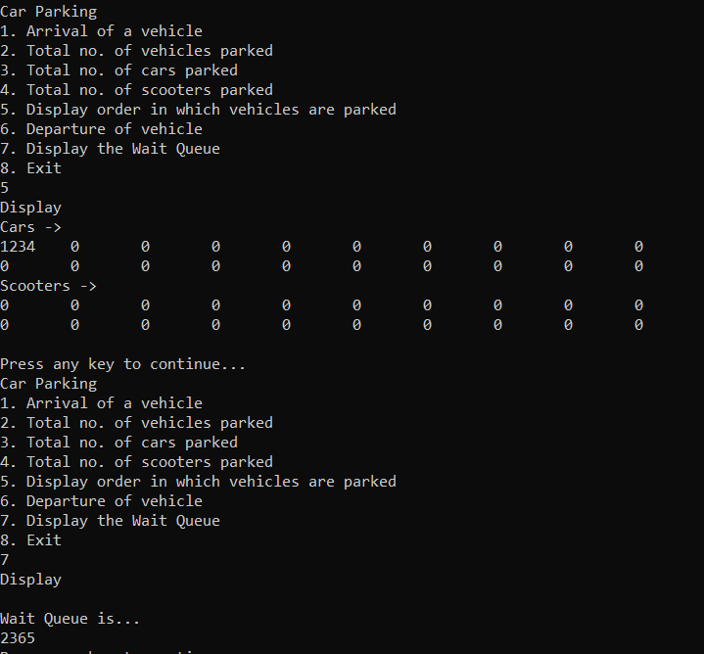

Figure : Screenshot of OUTPUT-2

Above figure shows the order of vehicles parked and waiting in the wait queue.

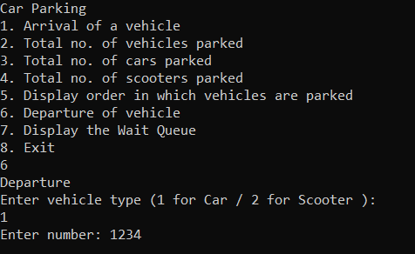

Figure : Screenshot of OUTPUT-3

Figure 8 shows the departure of vehicle from the parking slot.

We have successfully implemented our program for the two-wheelers also. It works same as four-wheelers but it two wheelers are assigned from the third row.

**4. Result**

We successfully designed the automatic parking system using binary semaphore. We have achieved what we thought before starting our project. The measure outcomings of our projects are:

1. Cost efficient as it uses very simple techniques and can be used in any type of machines.

2. It can be implemented in real world and solve the real issues.

3. It will save time for people as they just need to place their vehicle on the machine and then they are free to go.

4. Traffic will be reduced inside the parking spaces.

**5. Conclusion**

We have handled the parking problem using semaphore. Practical implementation of parking system can also be implemented using semaphores. Some more improvement in our project because it is a busy waiting solution so every vehicle has to wait until there space is available. If the problems are handled this can be a very good solution for the actual parking scenarios.

From this project we learnt a real-life scenario in which semaphores can be used. There are many such scenarios which can be efficiently handled by semaphores. Synchronization is required in many places around us, which tells us about the importance of semaphores.

**5.1 Future Work**

In this section, we discuss the limitations of our work and possible future directions.

In future we can expand our design and can avoid busy waiting problem which is unsolved now.

We can develop a program which will manage more than one machines at a time so that we can implement it to bigger parking spaces to save more time.

**5.2** **Acknowledgments**

We thank Vellore Institute of Technology for providing such an environment and encouragement to new comers like us. We also thank our guider Prof. VIJAYA KUMAR K for his continuous guidance and support.

We thank our friends and mentors for providing the constant feedback for our work.

**6.** **References**

[1] Lee, J. H. (2012). U.S. Patent No. 8,229,645. Washington, DC: U.S. Patent and Trademark Office.

[2] Jung, H. G., Kim, D. S., Yoon, P. J., & Kim, J. (2006, August). Structure analysis based parking slot marking recognition for semi-automatic parking system. In Joint IAPR International Workshops on Statistical Techniques in Pattern Recognition (SPR) and Structural and Syntactic Pattern Recognition (SSPR) (pp. 384-393). Springer, Berlin, Heidelberg.

[3] Gomaa, H. (1984). A software design method for real-time systems. Communications of the ACM, 27(9), 938-949.

[4] Sarkar, V. (1988, June). Synchronization using counting semaphores. In Proceedings of the 2nd international conference on Supercomputing (pp. 627-637). ACM.

[5] Sirithinaphong, T., & Chamnongthai, K. (1999). The recognition of car license plate for automatic parking system. In Signal Processing and Its Applications, 1999. ISSPA'99. Proceedings of the Fifth International Symposium on (Vol. 1, pp. 455-457). IEEE.

[6] Mehdipour, E., Mehdipour, F., Mehdipour, F., & Imani, K. (1986). U.S. Patent No. 4,603,390. Washington, DC: U.S. Patent and Trademark Office.

[7] Burns, L. D. (2013). Sustainable mobility: a vision of our transport future. Nature, 497(7448), 181.

[8] Rao, Y. R. (2017). Automatic smart parking system using Internet of Things (IOT). Int. J. Eng. Tech. Sci. Res, 4, 2394-3386.

[9] Vlahogianni, E. I., Kepaptsoglou, K., Tsetsos, V., & Karlaftis, M. G. (2016). A real-time parking prediction system for smart cities. Journal of Intelligent Transportation Systems, 20(2), 192-204.

[10] Kahn, P. R., Kinsolving, A., Vogel, D., & Christensen, M. A. (2018). U.S. Patent Application No. 10/043,388.

[11] Volz, C. M. (2017). U.S. Patent Application No. 15/390,028.

[12] Shahzad, A., Choi, J. Y., Xiong, N., Kim, Y. G., & Lee, M. (2018). Centralized Connectivity for Multiwireless Edge Computing and Cellular Platform: A Smart Vehicle Parking System. Wireless Communications and Mobile Computing, 2018.

[13] Bales, J., Hafner, M., Smith, K., & Lavoie, E. M. (2018). U.S. Patent No. 9,981,656. Washington, DC: U.S. Patent and Trademark Office.